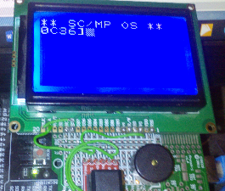**Release : Monitor 17**

Well, the arithmetic is done, though I do want to test it a bit more – at present it is only the four basic operations.

I’m considering adding a random number generator and ASCII -> integer functions to it. Probably in the opposite order.

I want to write some code to test the arithmetic functions better , especially multiply and divide – they seem to work as far as they go (e.g. the 16 x 16 bit multiply only yields 16 bit results and so on.

Memory-wise I have 256 bytes left of the ROM monitor. Though as you can see I’ve wasted 35 bytes of that on displaying a prompt when the machine first boots up. This is running on the replica , so far there seems to be no problems of consistency between the replica and the emulator at all, which is good ☺

Question of the day: how can Microsoft with all the improvement in CPU speeds etc. still have a word processor that runs worse than Windows 2.0 on a 386 ?